FINAL EXAMINATION
TIME ALLOWED: 90’
Subject: Linear Algebra. No books allowed.

1/ Find the matrix , such that 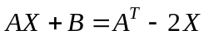, where 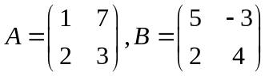.

2/ Find all real value(s) m such that 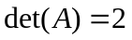, given that 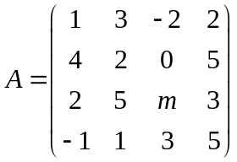.
3/ Let 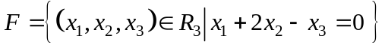 and
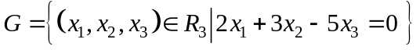 be two subspaces of the vector space 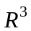.
Find one basic and a dimension of the intersection 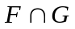.

4/ In with the inner product
, given the subspace 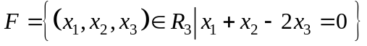 and two vectors 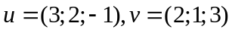.
Find the length of the vector 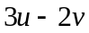 and the distance between and .

5/ Let 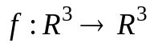 be the linear transformation.
Assume that .
a/ 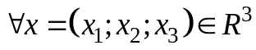, find 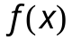.
b/ Find one basis and the dimension of the kernel of the mapping 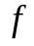.

6/ Let be the linear transformation and 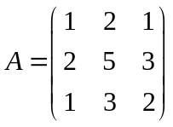 be the matrix of the linear transformation in the basis 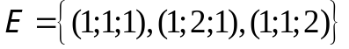. Compute 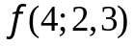

7/ Compute 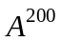, given that 

  

